**A tutorial:** [**Presentation of a software**](https://www.youtube.com/watch?v=wR0jg0eQsZA)

**1. Vocabulary.**

**A. Find a synonym for:** The words are in the chronological order.

basic (here but also implicit or hidden): **underlying**

an Excel table (for ex): **spreadsheet**

acquisition: **order**

a lead (to walk an animal): **a leash**

to log (= to register) (2 verbs, they follow each other): **to capture & to record**

superfluous: **redundant**

to associate with: **assign**

a section: **a field**

to buy: **purchase**

delivery: **shipment**

software (here): **tool**

**B. Phrases and phrasal verbs. Find the French equivalent to:**

to walk through: **guider / expliquer**

down the road: **à l’avenir**

to trickle in:

to pull in: **évoluer**

On the flip side: **à l’inverse**

fleshed out: **enrichir**

to start from scratch: **partir de zero**

**C. Neologism**

At the end, he uses a verb in the gerund form derived from the noun concept: “concepting”. Why doesn’t he use the noun conception? **Concepting : make a conception**

**2. Organising his speech and convincing:**

**A. This is a tutorial** so, the focus is mainly on what he shows. However, he uses some expressions to organize his demonstration efficiently. Complete them, they follow the chronological order of the video:

So, l_________________ you were opening…

Most ______________________ just open up a …

N________, you’ve got redundant information…

In_______________ of ha_______________ just one massive spreadsheet…

For ex________________, you m________________________ by _______________ a table that lists out all your Customers…

in a much ________________________________________way

______ you add or remove items…

L__________________________ to the Product table.

It’s ______________________________ that this system is far more organized… That’s ________ you …

_______ database management systems _____________________ don’t give …

That’s _________________ Entity Relationship Diagrams ___________________.

F__________________, the programmed connections between your tables, ….

So, __________________________ your database was far more fleshed out than our simple example. _____________ you…

T___________________________________ of a large database when you’re in the database can be very _________________.

**B. To try to convince** his product is better than E… by M…, he also used the comparative form. Revision [here](https://www.ego4u.com/en/cram-up/grammar/adjectives-adverbs/adjectives)

**C. Change of focus and use of passive.**

Look at these sentences from the video and transform the passive voice into the active voice. Sometimes, you will have to identify the subject, if you don’t know use “they”:

Shipments could get sent to the wrong place:

Customers might get mixed up:

this system is far more organized:

where improvements can be made:

your column categories are listed as attributes:

your database was far more fleshed out:

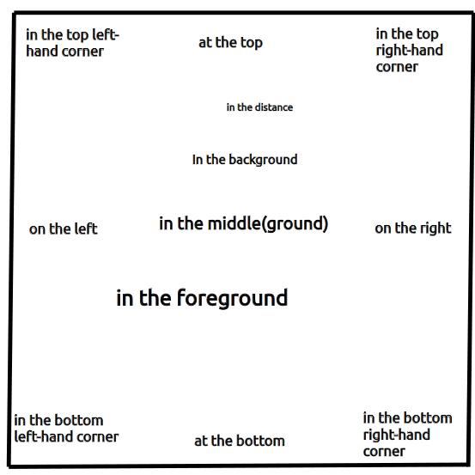**D. Spatial indicators:** This is an online tutorial, so he just needs to point or highlight. Sometimes, you present IRL, so you need to be able to use spatial indicators. And you need to avoid using “here” all the time!

This is a reminder of the common pointers:

Other useful pointers:

adjacent to

at the back / rear

at right angles (to)

close to

further

in the back /in (the) front

in the inner / lower / middle/ outer part

near / nearby

next to

on top of

perpendicular to